POCKETLAB TEST REPORT
Safe-State and BLE-Controlled Operation
AD5626 offset output and OP484 final-output transient evaluation
Project | PocketLab Programmable Function Generator
Test date | July 16, 2026 (Pacific Time)
Operating point | 1 kHz sine, 1.00 Vpp, 2.35 V offset
Acquisition | Analog Discovery 3 / WaveForms, DC-coupled dual-channel capture

Executive Summary
Overall result: PASS — no unsafe rail excursion was observed during configuration, OUTPUT ON, OUTPUT OFF, BLE disconnect, or ESP32 reset. The largest reset-related OP484 transient was 470.23 mV and lasted approximately 0.3–0.4 ms. Both outputs returned to the 0 V safe-off state.
Improvement identified: OUTPUT ON is electrically safe but not yet clean. The AD5626 steps to its programmed bias while the OP484 output briefly follows, returns near 0 V, and then develops the commanded waveform gradually. A mute/rebias/start/restore sequence is recommended for startup.

1. Test Objective
Verify safe behavior of the offset and final-output stages during cold/default operation and BLE-controlled state changes, with particular attention to unintended rail excursions, prolonged transients, unstable intermediate states, and the final logical safe state.
- Power-on with output logically off
- OUTPUT ON at 1 kHz, 1.00 Vpp, and 2.35 V offset
- OUTPUT OFF while running
- BLE disconnect while running
- ESP32 reset while running

2. Test Configuration
Item | Configuration | Purpose
CH1 | AD5626 output | Monitor programmed DC offset and safe-off behavior
CH2 | OP484 output | Monitor final externally presented waveform/output
Coupling | DC | Preserve offset and rail-transient information
Nominal supply | Approximately 4.71 V | Reference for unsafe positive-rail excursion
Safe-off target | 0 V physical output | Firmware retains logical settings while output is disabled

3. Acceptance Criteria
- No output approaches or remains at either supply rail.
- No sustained oscillation or unstable intermediate state occurs.
- OUTPUT OFF, BLE disconnect, and ESP32 reset restore the logical safe state and physical 0 V safe-off output.
- Any transient is documented by peak voltage, duration, settling behavior, and final state.

4. Results

4.1 Configuration Applied While Output Was Off
The app sent SET_STATE with FREQ=1000, AMP=1.00, OFFSET=2.35, and WAVE=SINE while OUTPUT remained OFF. Both observed nodes stayed near 0 V. This confirms that changing app controls stores the requested operating point without unexpectedly energizing the physical output.
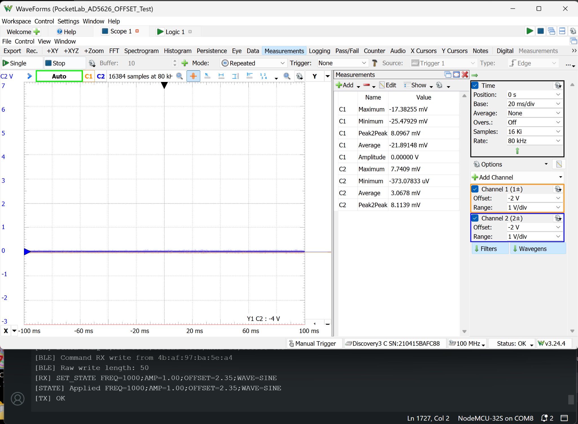
Figure 1. App configuration applied while OUTPUT was OFF; both physical outputs remain near 0 V.

4.2 OUTPUT ON
When OUTPUT ON was pressed, the AD5626 rose to approximately 2.34 V. The OP484 output initially followed the bias step, returned near 0 V, and then developed the 1 kHz waveform gradually. No excursion toward the 4.71 V supply rail was observed. The transition is safe, but the long waveform-envelope buildup is not an ideal instrument startup response.
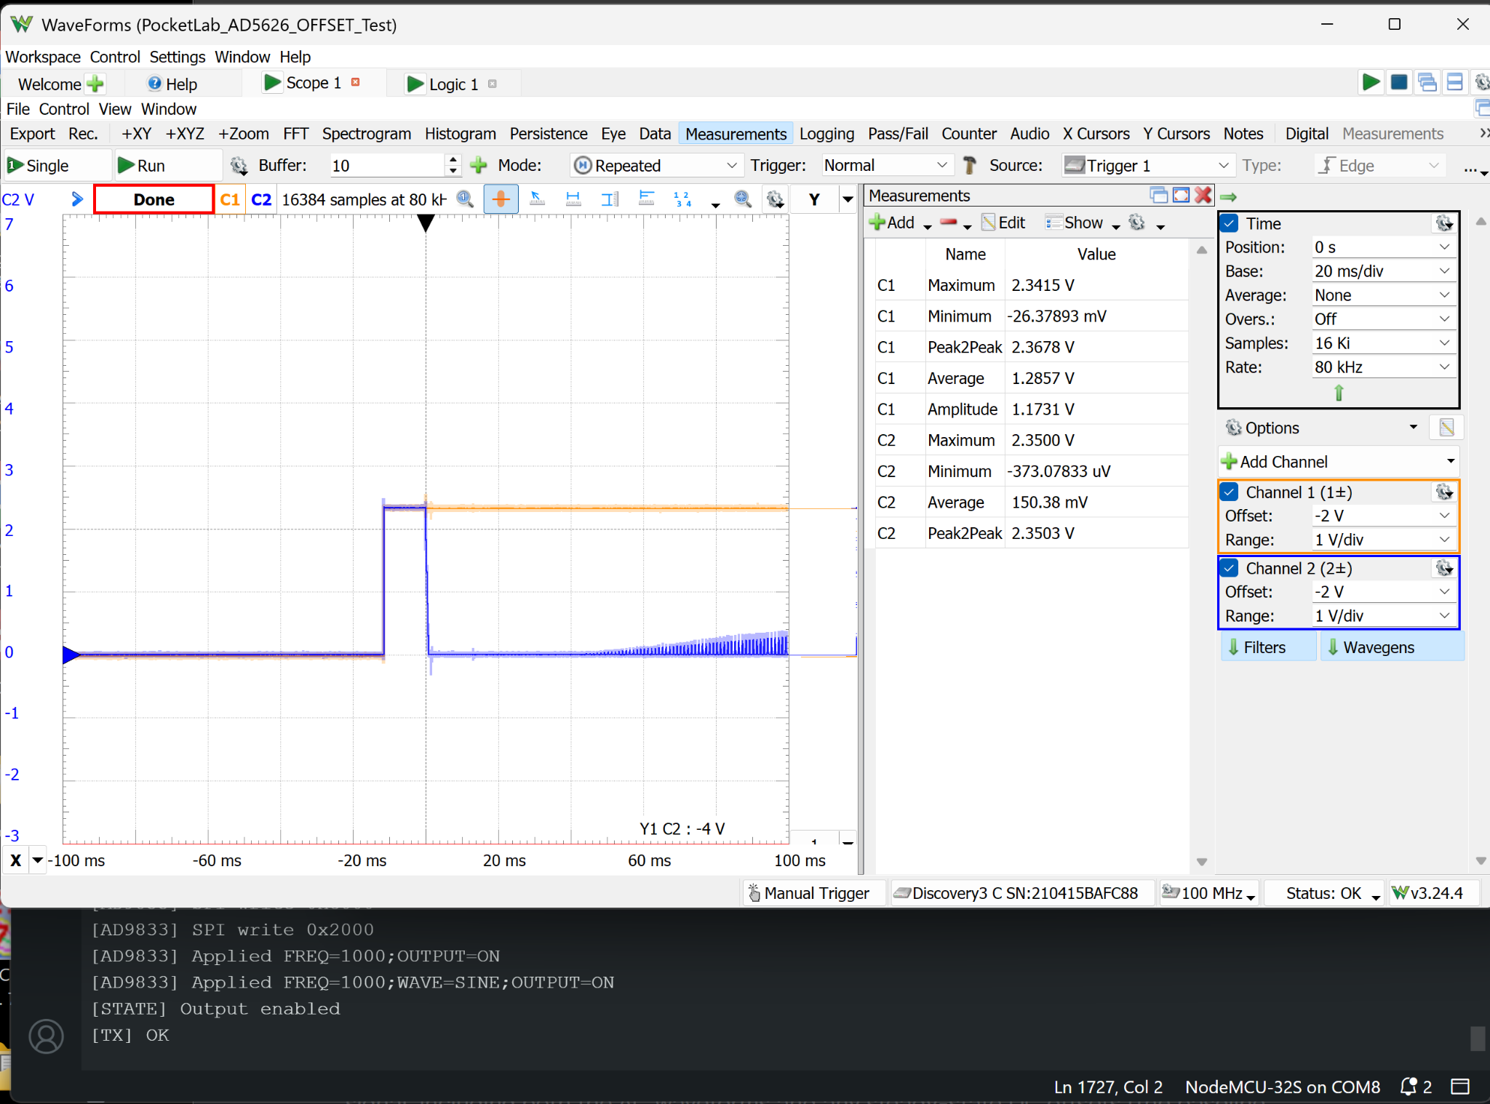
Figure 2. OUTPUT ON transition at 20 ms/div. CH1 steps to the offset level while the CH2 waveform envelope begins to develop.

4.3 OUTPUT OFF While Running
The waveform was first muted or stopped, leaving a flat level near 2.33 V for roughly 30 ms. The AD5626 and OP484 outputs then transitioned together to the 0 V safe-off level. The CH2 maximum of approximately 2.803 V is the normal upper peak of the commanded waveform, not a shutdown overshoot.
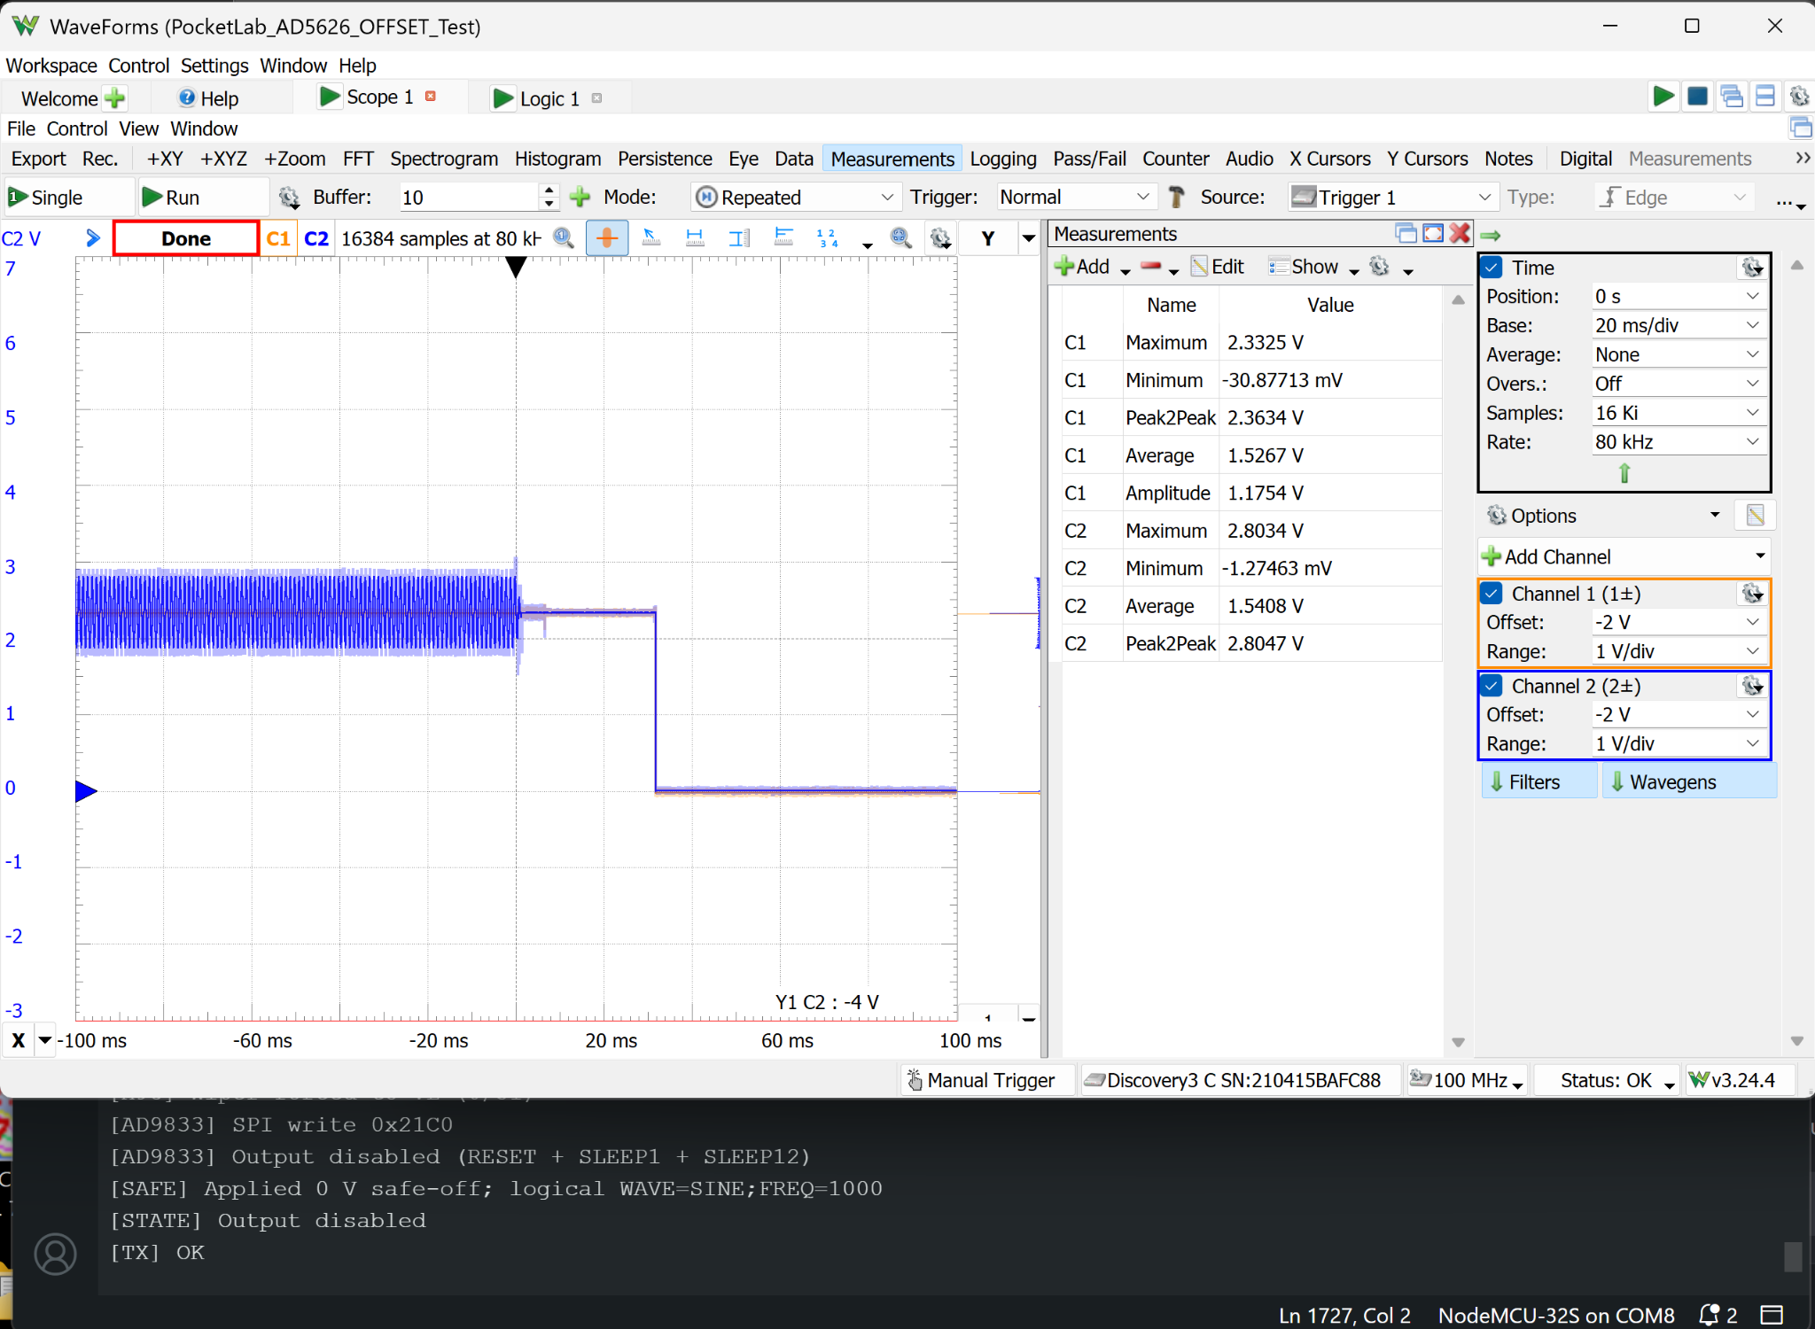
Figure 3. Explicit OUTPUT OFF command. The output is muted, briefly held near the bias level, and then placed at 0 V safe-off.

4.4 BLE Disconnect While Running
BLE disconnect produced nearly the same controlled shutdown as the explicit OUTPUT OFF command. Firmware logging confirmed that the X9C wiper was forced to VL and the AD9833 output was disabled. No unsafe excursion was observed, demonstrating that loss of the controlling client invokes the safe shutdown path.
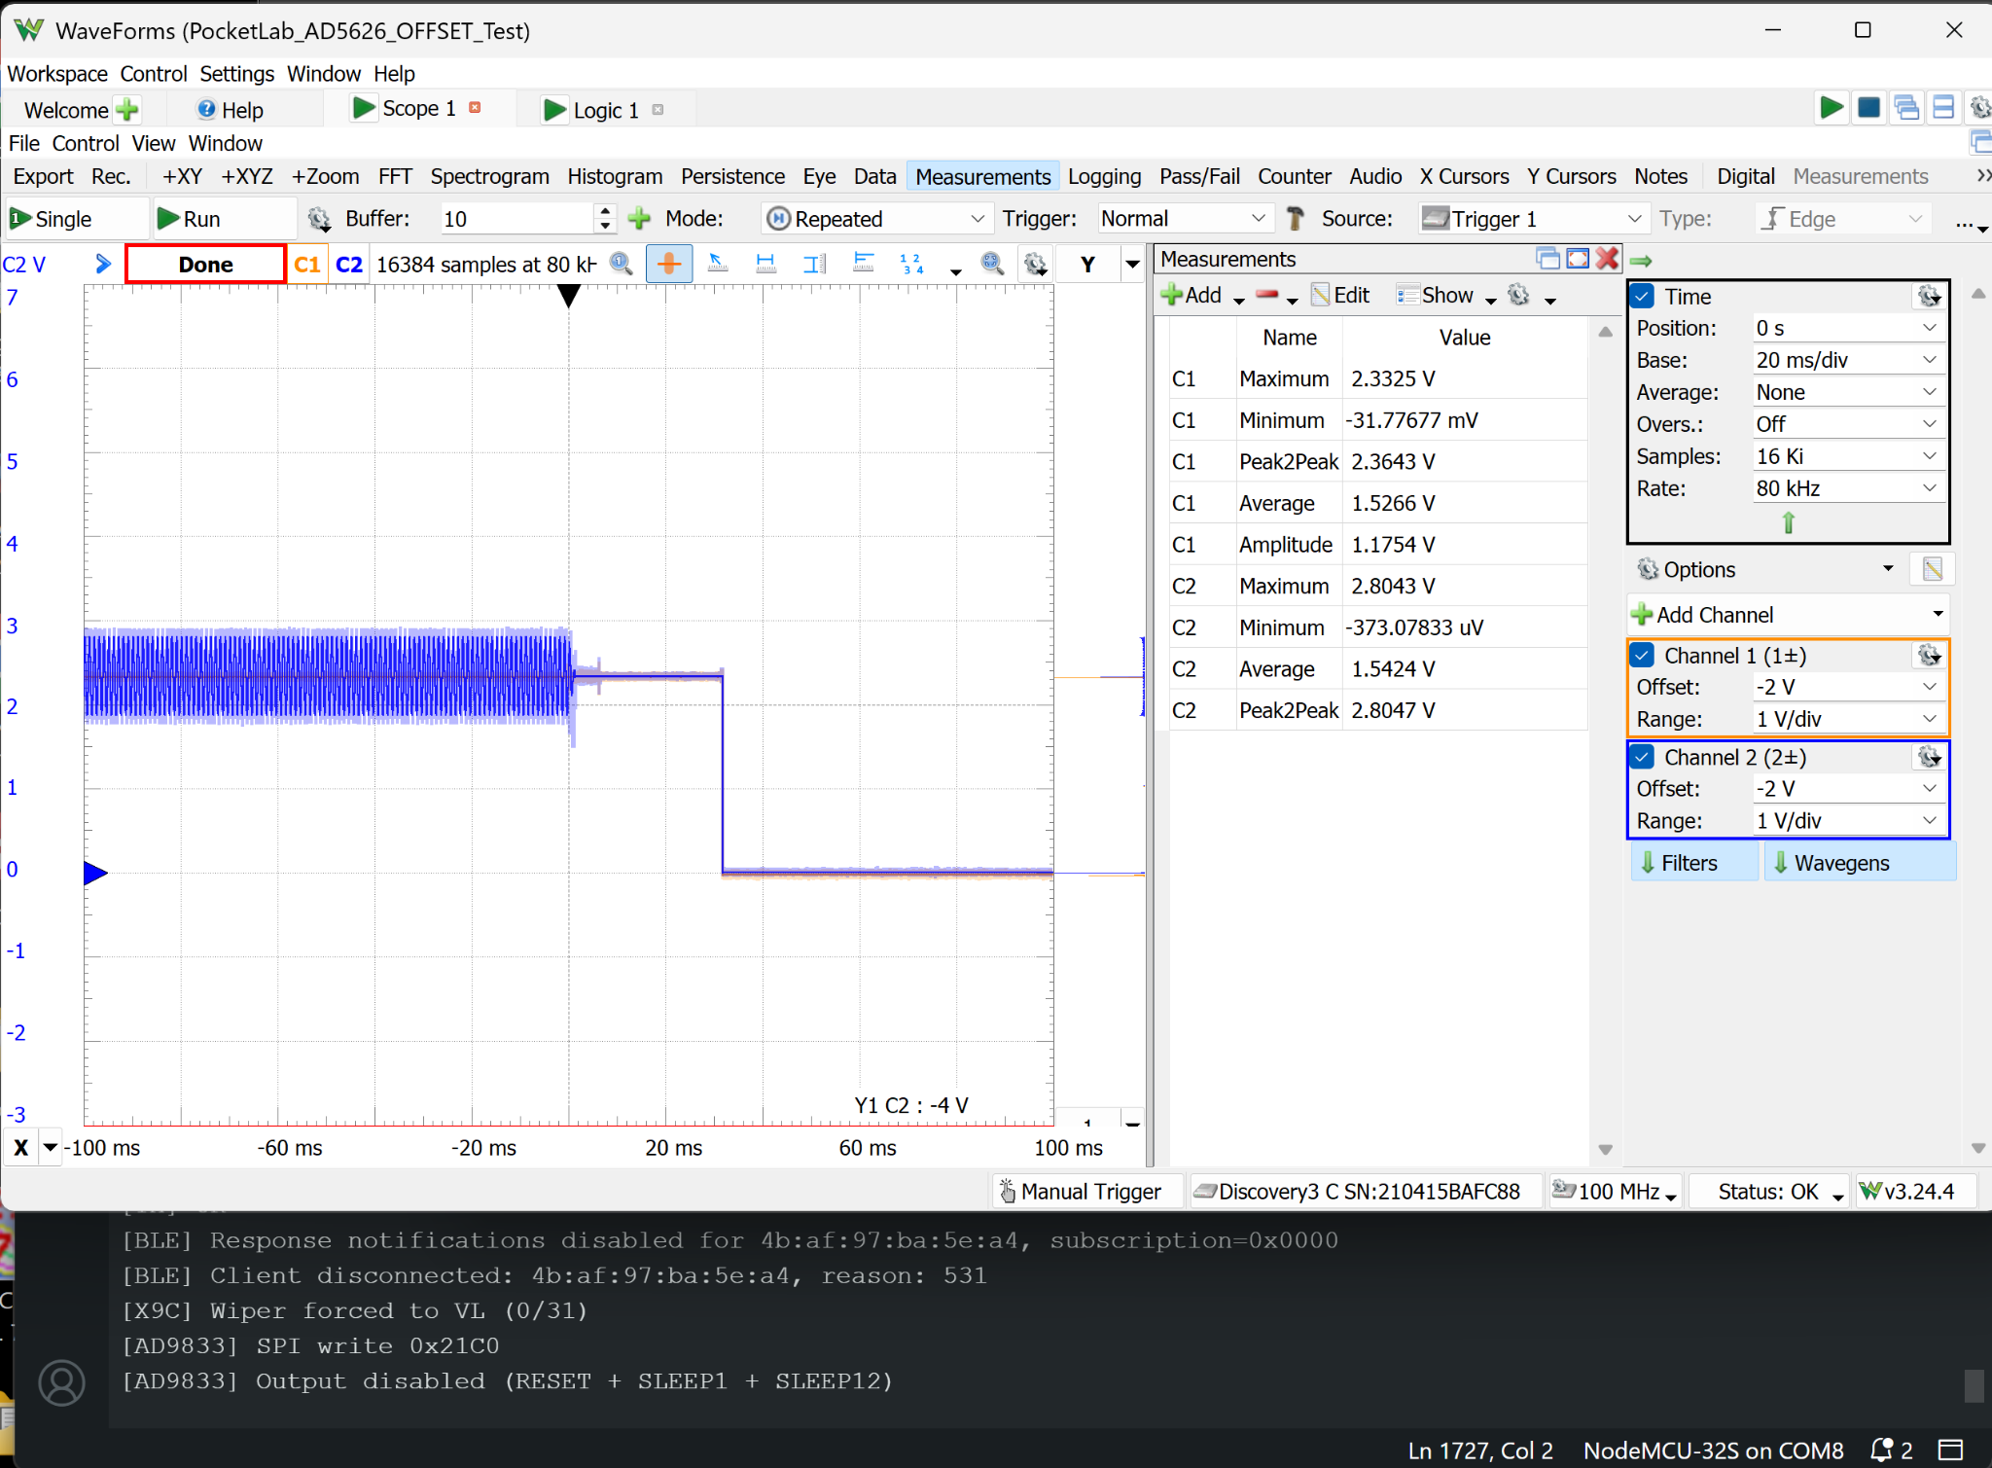
Figure 4. BLE disconnect while running; the controlled shutdown closely matches explicit OUTPUT OFF behavior.

4.5 ESP32 Reset While Running
During reset, the output collapsed to the safe-off level without a graceful application-controlled shutdown. A short, simultaneous positive pulse appeared at the AD5626 and OP484 outputs during restart. The close capture measured 436.04 mV maximum on CH1 and 470.23 mV maximum on CH2, with an estimated duration of 0.3–0.4 ms. The pulse remained far below the positive supply rail and was followed by a stable 0 V output.
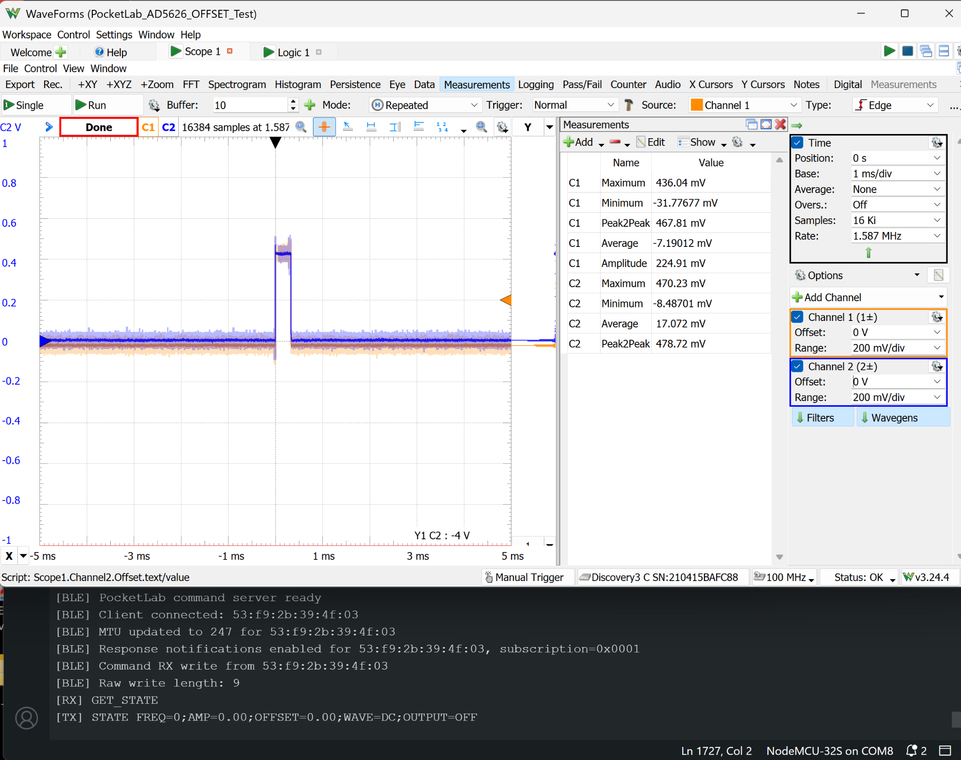
Figure 5. Close capture of the ESP32 reset transient at 1 ms/div and 1.587 MHz sample rate.

5. Consolidated Measurements
Test | AD5626 behavior | OP484 behavior | Transient / settling | Result
Configure while OFF | Remained near 0 V | Remained near 0 V | No commanded output | PASS
OUTPUT ON | 0 V → ≈2.34 V | Bias step, near-0 interval, gradual waveform buildup | Long envelope recovery; no rail excursion | PASS*
OUTPUT OFF | ≈2.33 V → 0 V | Waveform → ≈2.33 V → 0 V | ≈30 ms biased hold before safe-off | PASS
BLE disconnect | ≈2.33 V → 0 V | Waveform → ≈2.33 V → 0 V | Matches controlled shutdown | PASS
ESP32 reset | 436.04 mV max; −31.78 mV min | 470.23 mV max; −8.49 mV min | ≈0.3–0.4 ms pulse | PASS
* PASS for electrical safety; startup quality improvement recommended.

6. Conclusions and Recommendations
All required transitions met the primary safety objective: no unsafe excursion toward either supply rail occurred, and all fault-like events returned the instrument to the physical 0 V safe-off state. Explicit OUTPUT OFF and BLE disconnect use an effective controlled shutdown sequence. ESP32 reset produces only a small, brief restart pulse and correctly restores the logical default state.

Recommended OUTPUT ON sequence
- Keep the X9C amplitude path muted.
- Program the AD5626 to the requested offset and allow the bias network to settle.
- Start the AD9833 at the requested frequency and waveform while muted.
- Restore the requested amplitude in controlled steps.
- Report OUTPUT=ON after the restoration completes.
This sequence can remain invisible to the user: the app workflow stays unchanged, with one press of OUTPUT ON after selecting waveform, frequency, amplitude, and offset.

7. Final Disposition
SAFE-STATE / BLE OPERATION TEST: PASS
The hardware and firmware are suitable to proceed to refinement of the OUTPUT ON transition. No additional shutdown sequencing is required based on these captures; the existing OUTPUT OFF and disconnect behavior should be preserved during future firmware changes.

